**User Registration (Backend)**

1. *Project Creation*

*Created a new project with the following structure*

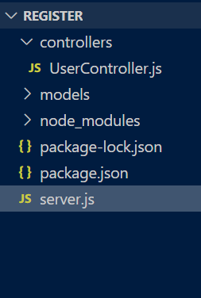

*2. Install node module*

*After the project create we install the node module with help of npm (Node Package Manager)*

*For instal go to tarminal and use npm Install <pacakege name> or use npm i<package name>*

*2.UserController.js*

*The main function is to be defined in this file.*

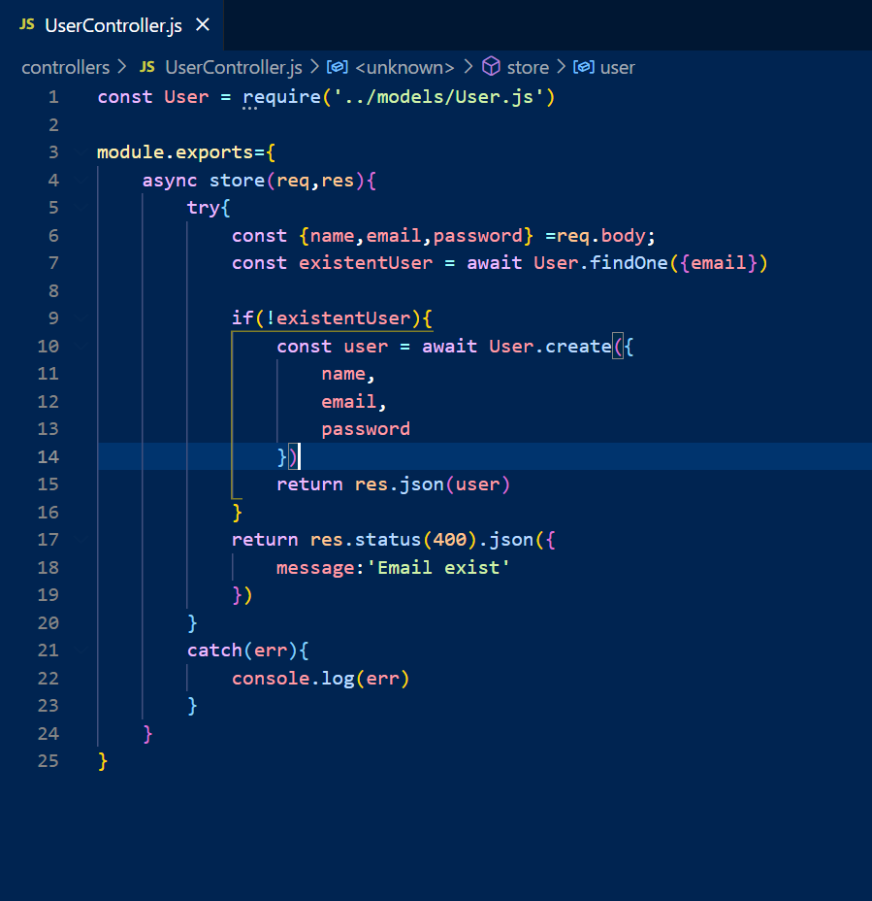

*1.***require():** *It is a special built-in function with special purpose to load modules. We use different syntax in different programming languages like in C its include, PHP its use, Python its import. A module cannot directly access things defined in another module unless it chooses to expose them.*

*2.***req,res:** *req is an object containing information about HTTP requests that raised the event. In response to req, we use res to send back the desired HTTP response.*

*3.***await:** *the await operator is used to wait for a Promise. It can only be used inside an async function within regular JS code, however it can be used on its own with JS modules.*

*4.***module.exports:** *It is used to expose a function/module, they must assigned to exports or module.exports and it must use require().*

*3.User.js*

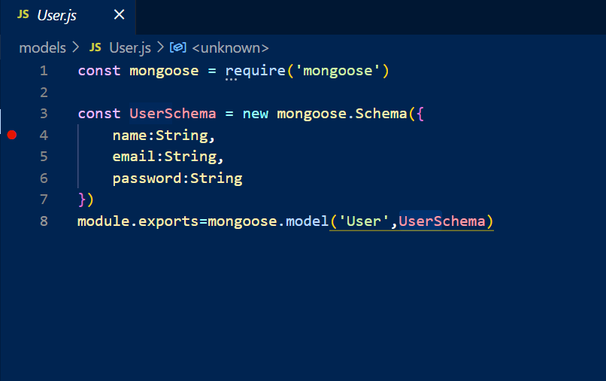

**1.Mongoose** *: It is an Object Data Modelling library for MongoDB and Node.js. It manages relationships between data, providers schema validation, and is used to translate between objects in code and representation of those objects in MongoDB.*

**2.schema:** *It is helpful because it allows us to take shortcuts in interpreting the vast amount of information that is available in our environment.*

**3.exports:** *It is used to export functions, objects or, primitive values form one module so that they can be used in other programs*

*4. Server.js*

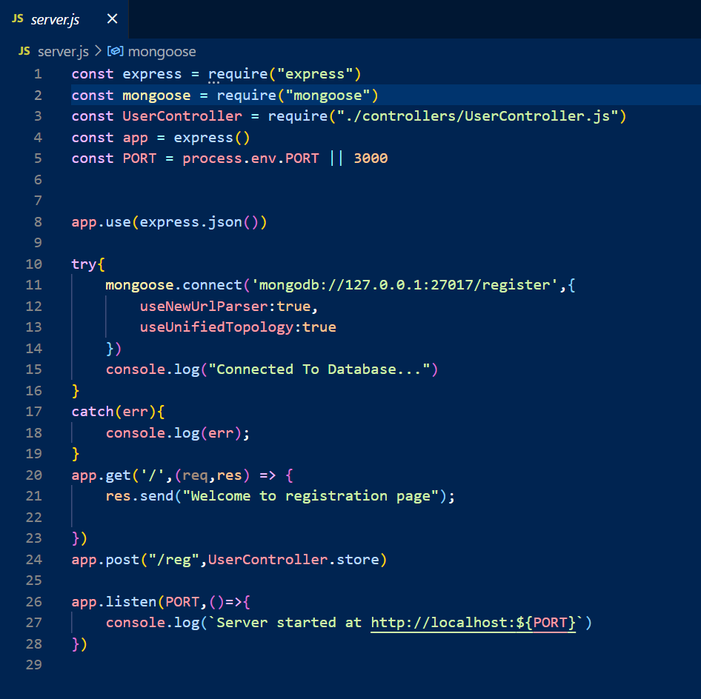

*1. Express: It is a framework that runs within Node.js that provides the means for a developer to create an d maintain robust servers.*

*2. .env: This file let us customize our working environment variables and it’s a hidden file*

*3. useNewUrlParser:true : This is added to allow user to fall back to old parser if we find a bug in a new parser.*

*useUnifiedTopology:true : It is set to true to using MongoDB driver’s new connection management engine.*

*4.get :**It is used for returning a specific element among all the elements which are present.*

*5. post:It allows us to send asynchronous http POST request to submit and retrieve the data from the server without reloading whole page.*

*6.PUT: It is used to send data to a server to create/update a resource.*

*The difference between POST and PUT is that PUT requests are idempotent. That is, calling the same PUT request multiple times will always produce the same result. In contrast, calling a POST request repeatedly have side effects of creating the same resource multiple times.*

*7. Patch : This method is used to apply partial modifications to a resource.*

The DELETE method deletes the specified resource.

*6. listen :**It is used to bind and listen the connection on the specific host and port.*

*POSTMAN*

*It is a software testing tool to test APIs. With this we can create, test, share and document APIs. It is a simple Graphic User Interface for sending and viewing HTTP requests and responses. It is used for backend testing where we enter the end-point URL, it sends the request for the server and receives the response back from server.*